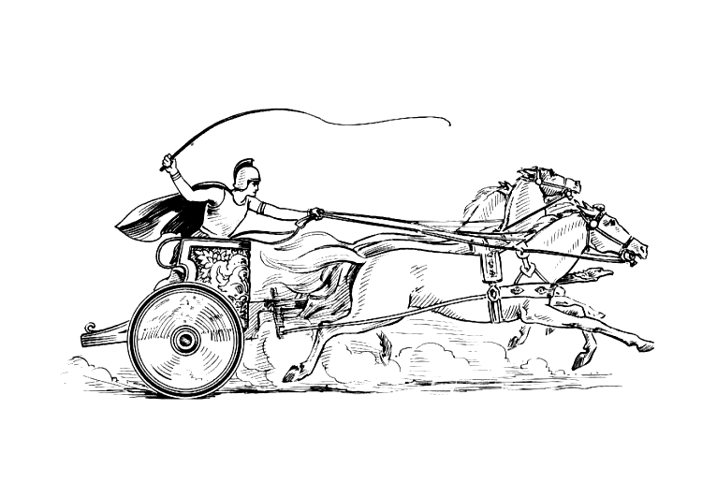Manduessedum - Mancetter Village (Place of War Chariots)
Mancetter Parish Council
Serving the People of Mancetter and Ridge Lane

You are invited to the Parish Council Meeting
to be held in the Schoolroom of St Peter’s Church Mancetter
on Tuesday 26th July 2022 at 7pm prompt.

AGENDA

- Welcome and Apologies.

- Chairman’s request that anyone recording the meeting to make themselves known.

- Notice of Interest.

- Public Question time up to 15 Minutes for Members of the Public to raise issues.

- Minutes of the last meeting:

- To accept the draft minutes of the Parish Council Meeting held on 24th May 2022.

- To review the draft minutes of the Annual Parish Meeting held on 26th April 2022 to be formally approved at the next Annual Parish Meeting on 25th April 2023.

- Matters Arising from the Parish Council Meeting on 24th May 2022 - not covered in any other agenda points

- Update on Community Speed Watch.
- Review of Mancetter Parish Jubilee Celebrations: Proposed Charity Auction and allocation of prizes.

- Report from the Police.

- Report from County and Borough Councillors.

- Finance

- Signing of all payments since the last meeting in accordance with the Bank mandate.
- Financial Report for the first quarter of the financial year April – June 2022

- Planning Matters and New Applications since the previous meeting:

- Update on Enforcement issues:

CMP/2022/00034 – Land at Rear of 90-92 Mancetter Road.

- Update on Approved and Pending Applications:
PAP/2020/0227 Barn Fishery – Withdrawn
PAP/2021/0044 Barn Fishery - Refused

- To discuss any new applications received:

PAP/2022/0258 7 Tom Piper Close Ridge Lane –
Erection of Edwardian Conservatory

PAP/2022/0305 “Little Close” Quarry Lane Mancetter –
Erection of hay and feed store for agricultural use.

- To respond to a proposal for diverting Bridleway AE109X

- Cemetery and Maintenance around the Parish

- Confirmation of purchase of new Cemetery Deed Book.
- To open the new Cemetery Area for Scattering Ashes and discuss commemorative records kept by the Parish.
- Approach local businesses for “Memorial Jubilee Avenue” signage suitable for the conservation area and liaise with NWBC.
- To discuss an amendment to the policy for setting Cemetery Fees to recognise official public service within the parish for out of parish residents.

- Date of next meetings-

Wednesday 21st September 2022
7pm Mancetter Memorial Hall
(Informal Meeting with Parishioners / Proposed Charity Auction)

Tuesday 27th September 2022 – Parish Council Meeting.

7pm at St Peter’s Church Mancetter.

Signed

Date 21st July 2022.

Elane Higgins
Parish Clerk Mancetter Memorial Hall Old Farm Road Mancetter CV9 1QN Tel: 01827 722552 Email: parishclerk@mancetter.org.uk
Website: www.mancetter.org.uk

